Spatial Spectral Estimation

P. Sai Teja

2022EEE2709

Question 1:

a)

All the methods give correct estimates in the presence of AWGN and the chosen DoA’s (0,15). Yes, the properties of these estimators are analogous to the two sinusoid case in time series showing spatial sampling and time sampling are similar.

b)

Beamforming method gave a single peak in the presence of two sources at (0,7.5) DoA’s suggesting that only source is present. Other methods estimated better. Beamforming method replicated the case where the second signal has lesser power than the first signal. But in the selected scenario, all the transmitted signals have equal power.

Question 2:

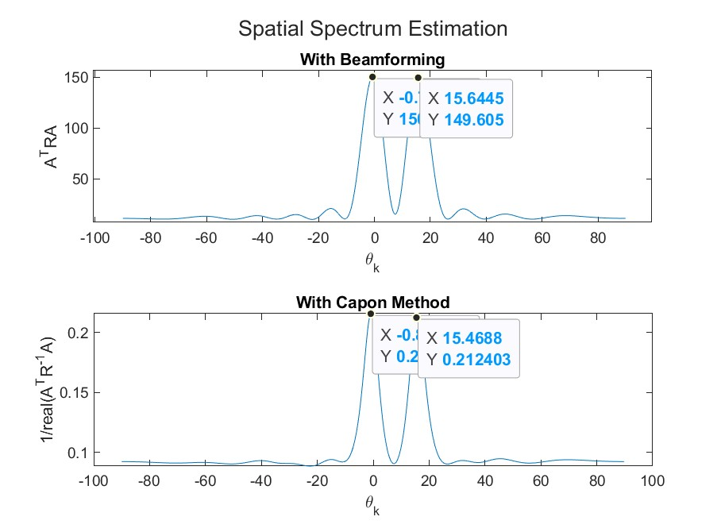

Except ESPRIT all the methods performed better in the presence of coherent sources.

Question 3:

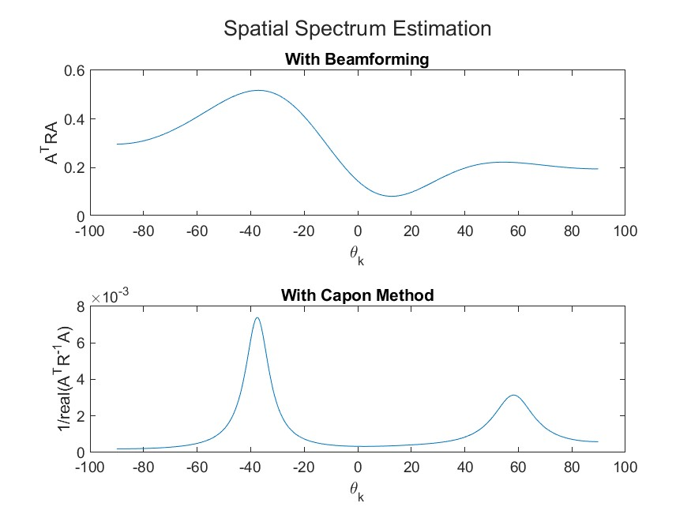

The above plots suggest that there are two sources a.k.a two submarines around -40,55 degrees. Using the sub-space methods also suggests the same DoA assuming number of submarines as 2, as shown below.

